CHADD Presents an Interactive and Informative Program on
“The ADHD Effect on Relationships between spouses, children and in families"
Wed. November 7, 2018, 7 pm
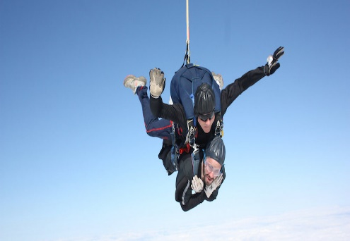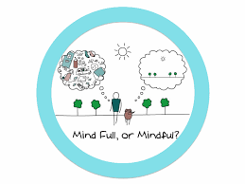
Bring your Significant other!
Presented by Todd Schmenk, AQAL THERAPIES Providence,RI
Todd is a mental health counselor helping individuals to Thrive.
T: 401-384-0701 E: Todd@Toddschmenk.com https://www.aqaltherapies.com
Bradley Hospital- Pine Room 1011 Veterans Memorial Pkwy East Providence, RI
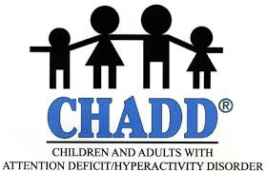
RSVP NOT necessary. No charge. Donations appreciated.
Contact: Roberta 401-369-0045
www.CHADD.org Email: rhode-island@chadd.org

CHADD Presents an Informative Program on
ADHD & Functional Psychiatry
Wednesday, To be determined , 7 pm
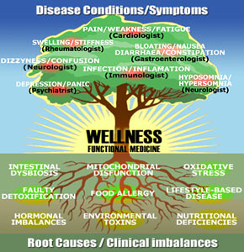
Functional medicine teaches that all parts of the body and brain can be affected by chronic illness, with the common denominator being Inflammation. Inflammation in the brain can manifest as all of the psychiatric disorders (Depression, Anxiety, ADHD, OCD, Bipolar, PTSD, Psychosis) and also the Neurodegenerative Disorders (Alzheimer's, Mild Cognitive Impairment etc.).
The road to wellness then starts with the search for what is driving the inflammation, and putting out the source of that fire, rather than simply covering up one manifestation of the inflammation (like Depression or ADHD) without addressing it's root cause.
The program will offer participants an opportunity to network, express challenges and get answers to their medical questions.
Presented by examines blood work and DNA results to see what your body's unique needs are then uses micronutrients, diet, hormones, herbal supplements and medications when needed. Her Functional Psychiatry techniques help improve: ADHD, Depression, Anxiety which are often not helped by medications alone. Bradley Hospital- Pine Room 1011 Veterans Memorial Pkwy East Providence, RI
RSVP NOT necessary. No charge. Donations appreciated.
Contact: Roberta 401-369-0045
www.CHADD.org E-mail: rhode-island@chadd.org

