CHADD of Rhode Island

Have ADHD or know someone who does?

Learn from the pros about…..
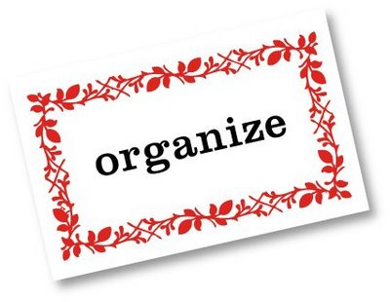

Personalized plans for families, children, and adults affected by ADHD to stay organized, manage time, complete work, and keep track of important belonging which can all be difficult daily struggles.

Wednesday, March 6, 7 pm

- with Betsy Alper, LICSW, clinical social worker She knows that one size does not fit all when it comes to helping families affected by ADD/ADHD! Betsy uses home visits, phone consultations, and email and text support, with a detailed plan along with the structure, support, and accountability to help her clients. www.addstrategiesandsolutions.com
- And Lisa Proctor, Holistic Counselor, who takes the whole person and life experiences into consideration using spiritual and out of the box techniques.

Place: Bradley Hospital ~Pine Room 1011 Veterans Memorial Pkwy E. Prov. ,RI

Donations appreciated from guests. Members: Free
Website: www.chadd.org Local: www.chadd.net/810 Email: rhode-island@chadd.net Phone: 401-369-0045
Reservations NOT necessary. All welcome.

