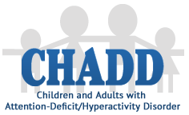

Western Wayne County CHADD

Meets on select Monday nights @ 7:00 p.m.
Northville High School, Room 141
45700 Six Mile Road, Northville, MI 48168
Hear from the experts about different aspects of ADHD
Learn from others who have been “down the road”

Parent better because you understand more
Come to a CHADD meeting!

For more information email us at chaddwwmi@gmail.com

Follow us on Facebook & the CHADD website for updates.

Meeting Dates for the 2015-16 school year:
September 14
October 12
November 16
December 14
January 11
February 22
March 21
April 18
May 16

